Implement SVM/Decision tree classification technique

**AIM:**

To Implement SVM and Decision tree classification techniques using R programming in R Studio.

# SVM IN R

# Install and load the e1071 package (if not already installed) install.packages("e1071") library(e1071)

# Load the iris dataset data(iris)

# Inspect the first few rows of the dataset head(iris)

# Split the data into training (70%) and testing (30%) sets set.seed(123) # For reproducibility

sample_indices <- sample(1:nrow(iris), 0.7 * nrow(iris)) train_data <- iris[sample_indices, ] test_data <- iris[- sample_indices, ]

# Fit the SVM model svm_model <- svm(Species ~ ., data = train_data, kernel = "radial")

# Print the summary of the model summary(svm_model)

# Predict the test set predictions <- predict(svm_model, newdata = test_data)

# Evaluate the model's performance

confusion_matrix <- table(Predicted = predictions, Actual = test_data$Species) print(confusion_matrix)

# Calculate accuracy accuracy <- sum(diag(confusion_matrix)) / sum(confusion_matrix) cat("Accuracy:", accuracy * 100, "%\n")

# OUTPUT:

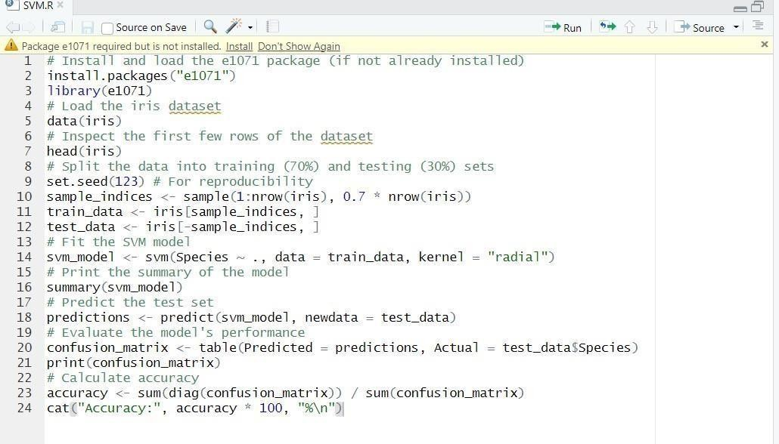

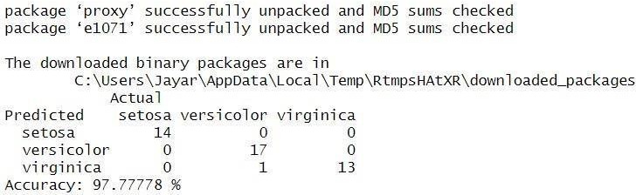

1. **Decision tree in R**

# Install and load the rpart package (if not already installed) install.packages("rpart") library(rpart)

# Load the iris dataset data(iris)

# Split the data into training (70%) and testing (30%) sets set.seed(123) # For reproducibility

sample_indices <- sample(1:nrow(iris), 0.7 * nrow(iris)) train_data <- iris[sample_indices, ] test_data <- iris[- sample_indices, ]

# Fit the Decision Tree model tree_model <- rpart(Species ~

., data = train_data, method = "class")

# Print the summary of the model summary(tree_model) # Plot the Decision Tree

plot(tree_model) text(tree_model, pretty =

0)

# Predict the test set predictions <- predict(tree_model, newdata = test_data, type = "class")

# Evaluate the model's performance

confusion_matrix <- table(Predicted = predictions, Actual = test_data$Species) print(confusion_matrix)

# Calculate accuracy

accuracy <- sum(diag(confusion_matrix)) / sum(confusion_matrix) cat("Accuracy:", accuracy * 100, "%\n")

# OUTPUT:

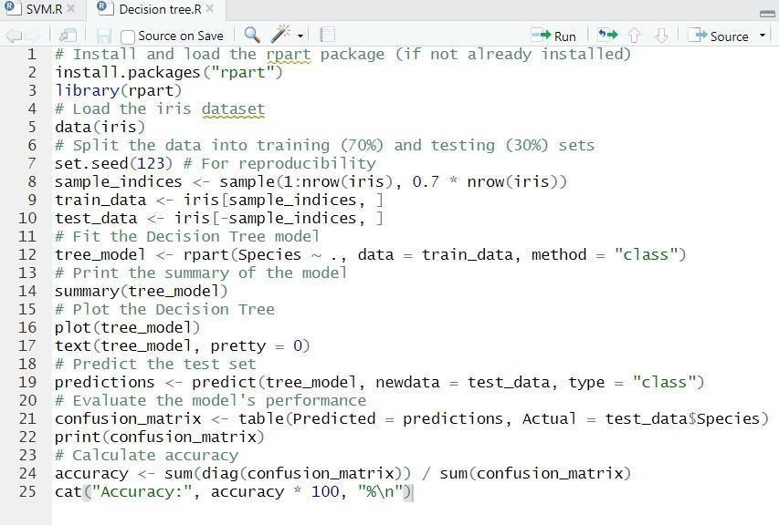

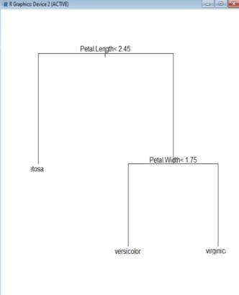

**RESULT:**

Thus, the Implementation SVM/Decision tree classification techniques using R programming in R Studio.